
Name: Kachhadiya janvi
Enroll No: 202500819010013

- LoginRegister
  - LoginRegister
    - urls.py
from django.contrib import admin
from django.urls import path, include

urlpatterns = [
path('admin/', admin.site.urls),
path('', include('login.urls'))
]
    - settings.py
INSTALLED_APPS = [
'django.contrib.admin',
'django.contrib.auth',
'django.contrib.contenttypes',
'django.contrib.sessions',
'django.contrib.messages',
'django.contrib.staticfiles',
'login'
]

  - Login
    - urls.py
from django.urls import path
from . import views

urlpatterns = [
path("login/", views.login_view, name="login"),
path("register/", views.register_view, name="register"),
path("logout/", views.logout_view, name="logout"),
path("", views.dashboard_view, name="dashboard"),
path("product/", views.home, name="product"),
path('add-product/', views.add_product, name='add_product'),
path('edit/<int:pk>/', views.edit_product, name='edit_product'),
path('delete/<int:pk>/', views.delete_product, name='delete_product'),
]

    - view.py
from django.shortcuts import render, redirect, get_object_or_404
from django.contrib.auth.models import User
from django.contrib.auth import authenticate, login, logout
from django.contrib import messages
from .models import Product
from .forms import ProductForm

def register_view(request):
if request.user.is_authenticated:
return redirect("dashboard")

if request.method == "POST":
username = request.POST.get("username")
email = request.POST.get("email")
password = request.POST.get("password")

if User.objects.filter(username=username).exists():
messages.error(request, "Username already exists")
return redirect("register")
if User.objects.filter(email=email).exists():
messages.error(request, "Email already exists")
return redirect("register")

user = User.objects.create_user(username=username, email=email, password=password)
user.save()
messages.success(request, "Account created successfully")
return redirect("login")

return render(request, "register.html")

def login_view(request):
if request.user.is_authenticated:
return redirect("dashboard")

if request.method == "POST":
email = request.POST.get("email")
password = request.POST.get("password")

try:
user_obj = User.objects.get(email=email)
username = user_obj.username
except User.DoesNotExist:
messages.error(request, "Invalid email or password")
return redirect("login")

user = authenticate(request, username=username, password=password)

if user is not None:
login(request, user) # session created
return redirect("dashboard")
else:
messages.error(request, "Invalid credentials")

return render(request, "login.html")

def logout_view(request):
logout(request)
return redirect("login")

def dashboard_view(request):
if not request.user.is_authenticated:
return redirect("login")
return render(request, "dashboard.html")

def home(request):
if not request.user.is_authenticated:
return redirect("login")
products = Product.objects.all()
context = {
'products': products,
}
return render(request, 'home.html', context)

def add_product(request):
if not request.user.is_authenticated:
return redirect("login")
if request.method == 'POST':
form = ProductForm(request.POST)
if form.is_valid():
form.save()
messages.success(request, f"Product '{form.cleaned_data['name']}' added successfully!")
return redirect('product')
else:
form = ProductForm()

return render(request, 'add_product.html', {'form': form})

def edit_product(request, pk):
if not request.user.is_authenticated:
return redirect("login")
product = get_object_or_404(Product, pk=pk)
if request.method == 'POST':
form = ProductForm(request.POST, instance=product)
if form.is_valid():
form.save()
messages.success(request, f"Product '{form.cleaned_data['name']}' updated successfully!")
return redirect('product')
else:
form = ProductForm(instance=product)

return render(request, 'edit_product.html', {'form': form, 'product': product})

def delete_product(request, pk):
if not request.user.is_authenticated:
return redirect("login")
product = get_object_or_404(Product, pk=pk)
if request.method == 'POST':
product.delete()
messages.success(request, f"Product '{product.name}' deleted successfully!")
return redirect('product')
return render(request, 'delete_product.html', {'product': product})

    - admin.py
from django.contrib import admin
from .models import Product

# Register your models here.
admin.site.register(Product)

    - models.py
from django.db import models

# Create your models here.
class Product(models.Model):
name = models.CharField(max_length=100)
price = models.DecimalField(max_digits=10, decimal_places=2)
quantity = models.PositiveIntegerField()

def __str__(self):
return self.name

    - forms.py
from django import forms
from .models import Product

class ProductForm(forms.ModelForm):
class Meta:
model = Product
fields = ['name', 'price', 'quantity']

widgets = {
'name': forms.TextInput(attrs={
'class': 'form-control',
'placeholder': 'Enter product name',
}),
'price': forms.NumberInput(attrs={
'class': 'form-control',
'placeholder': 'Enter Price',
'step': '0.01',
}),
'quantity': forms.NumberInput(attrs={
'class': 'form-control',
'placeholder': 'Enter Quantity',
'min': '0',
}),
}

    - Templates
        - Add_product.html
{% load static %}
<!DOCTYPE html>
<html>
<head>
<title>Dashboard</title>

<!-- Google Font -->
<link href="https://fonts.googleapis.com/css2?family=Poppins&display=swap" rel="stylesheet">
<link rel="stylesheet" href="https://cdnjs.cloudflare.com/ajax/libs/font-awesome/6.5.0/css/all.min.css">
<link href="https://cdn.jsdelivr.net/npm/bootstrap@5.3.3/dist/css/bootstrap.min.css" rel="stylesheet">
<link rel="stylesheet" href="{% static 'css/inventory.css' %}">
<!-- Poppins font -->
<link href="https://fonts.googleapis.com/css2?family=Poppins:ital,wght@0,100;0,200;0,300;0,400;0,500;0,600;0,700;0,800;0,900;1,100;1,200;1,300;1,400;1,500;1,600;1,700;1,800;1,900&display=swap" rel="stylesheet">

<style>
body {
margin: 0;
padding: 0;
font-family: 'Poppins', sans-serif;
display: flex;
background: #f4f7fe;
}

/* Sidebar */
.sidebar {
width: 230px;
height: 100vh;
background: linear-gradient(to bottom, #1e3c72, #2a5298);
color: white;
position: fixed;
padding-top: 20px;
}

.sidebar h2 {
text-align: center;
margin-bottom: 30px;
}

.sidebar a {
display: block;
padding: 12px 20px;
color: white;
text-decoration: none;
transition: 0.3s;
}

.sidebar a:hover {
background: rgba(255,255,255,0.2);
padding-left: 25px;
}

/* Main */
.main {
margin-left: 230px;
width: 100%;
}

/* Topbar */
.topbar {
background: white;
padding: 15px 25px;
display: flex;
justify-content: space-between;
align-items: center;
box-shadow: 0 2px 10px rgba(0,0,0,0.05);
}

.profile {
display: flex;
align-items: center;
}

.profile img {
width: 40px;
border-radius: 50%;
margin-right: 10px;
}

/* Content */
.content {
padding: 25px;
}

/* Cards Grid */
.grid {
display: grid;
grid-template-columns: repeat(4, 1fr);
align-items: center;
gap: 20px;
justify-content: center;
}

.card {
background: white;
padding: 20px;
border-radius: 12px;
box-shadow: 0 5px 15px rgba(0,0,0,0.05);
transition: 0.3s;
}

.card:hover {
transform: translateY(-5px);
}

.card h4 {
margin: 0;
font-size: 22px;
color: #1e3c72;
}

.card span {
font-size: 14px;
color: gray;
}

/* Chart + Layout */
.bottom-grid {
display: grid;
grid-template-columns: 2fr 1fr;
gap: 20px;
margin-top: 20px;
}

canvas {
width: 100% !important;
}

/* Chat Box */
.chat {
max-height: 300px;
overflow-y: auto;
}

.chat-item {
padding: 10px;
cursor: pointer;
border-bottom: 1px solid #eee;
}

.chat-item:hover {
background: #a3bff1;
border-radius: 10px;
}

.logout {
background: #fff;
color: #1e3c72;
padding: 6px 12px;
border-radius: 5px;
text-decoration: none;
margin-left: 10px;
}
.card:nth-child(1) i { color: #4CAF50; } /* green */
.card:nth-child(2) i { color: #2196F3; } /* blue */
.card:nth-child(3) i { color: #FF9800; } /* orange */
.card:nth-child(4) i { color: #E91E63; }
.icon {
font-size: 28px;
color: #2a5298;
margin-bottom: 10px;
display: block;
}

/* Optional: fancy icon background */
.card i {
background: rgba(42,82,152,0.1);
padding: 12px;
display: inline-block;
border-radius: 50%;
}

</style>
</head>
<body>

<!-- Sidebar -->
<div class="sidebar">
<h2>MyPanel</h2>
<a href="{% url 'dashboard' %}">Dashboard</a>
<a href="{% url 'product' %}">Inventory</a>
<a href="/logout/">Logout</a>
</div>
<div class="main">

<!-- Topbar -->
<div class="topbar">
<h3>Dashboard</h3>

<div class="profile">
<img src="https://cdn-icons-png.flaticon.com/512/149/149071.png">
{{ request.user.username }}
</div>
</div>

<!-- Content -->
<div class="container mt-5">
<h2>Add New Product</h2>

<form method="post">
{% csrf_token %}
{{ form.as_p }}
<button type="submit" class="btn btn-primary">Add Product</button>
<a href="{% url 'product' %}" class="btn btn-secondary">Back to Inventory</a>
</form>
</div>

</div>

<script src="https://cdn.jsdelivr.net/npm/bootstrap@5.3.3/dist/js/bootstrap.bundle.min.js"></script>
</body>
</html>

        - Dashboard.html
{% load static %}
<!DOCTYPE html>
<html>
<head>
<title>Dashboard</title>

<!-- Google Font -->
<link href="https://fonts.googleapis.com/css2?family=Poppins&display=swap" rel="stylesheet">
<link rel="stylesheet" href="https://cdnjs.cloudflare.com/ajax/libs/font-awesome/6.5.0/css/all.min.css">
<link rel="stylesheet" href="https://cdnjs.cloudflare.com/ajax/libs/font-awesome/6.5.0/css/all.min.css">
<link rel="stylesheet" href="{% static 'css/inventory.css' %}">

<style>
body {
margin: 0;
padding: 0;
font-family: 'Poppins', sans-serif;
display: flex;
background: #f4f7fe;
}

/* Sidebar */
.sidebar {
width: 230px;
height: 100vh;
background: linear-gradient(to bottom, #1e3c72, #2a5298);
color: white;
position: fixed;
padding-top: 20px;
}

.sidebar h2 {
text-align: center;
margin-bottom: 30px;
}

.sidebar a {
display: block;
padding: 12px 20px;
color: white;
text-decoration: none;
transition: 0.3s;
}

.sidebar a:hover {
background: rgba(255,255,255,0.2);
padding-left: 25px;
}

/* Main */
.main {
margin-left: 230px;
width: 100%;
}

/* Topbar */
.topbar {
background: white;
padding: 15px 25px;
display: flex;
justify-content: space-between;
align-items: center;
box-shadow: 0 2px 10px rgba(0,0,0,0.05);
}

.profile {
display: flex;
align-items: center;
}

.profile img {
width: 40px;
border-radius: 50%;
margin-right: 10px;
}

/* Content */
.content {
padding: 25px;
}

/* Cards Grid */
.grid {
display: grid;
grid-template-columns: repeat(4, 1fr);
align-items: center;
gap: 20px;
justify-content: center;
}

.card {
background: white;
padding: 20px;
border-radius: 12px;
box-shadow: 0 5px 15px rgba(0,0,0,0.05);
transition: 0.3s;
}

.card:hover {
transform: translateY(-5px);
}

.card h4 {
margin: 0;
font-size: 22px;
color: #1e3c72;
}

.card span {
font-size: 14px;
color: gray;
}

/* Chart + Layout */
.bottom-grid {
display: grid;
grid-template-columns: 2fr 1fr;
gap: 20px;
margin-top: 20px;
}

canvas {
width: 100% !important;
}

/* Chat Box */
.chat {
max-height: 300px;
overflow-y: auto;
}

.chat-item {
padding: 10px;
cursor: pointer;
border-bottom: 1px solid #eee;
}

.chat-item:hover {
background: #a3bff1;
border-radius: 10px;
}

.logout {
background: #fff;
color: #1e3c72;
padding: 6px 12px;
border-radius: 5px;
text-decoration: none;
margin-left: 10px;
}
.card:nth-child(1) i { color: #4CAF50; } /* green */
.card:nth-child(2) i { color: #2196F3; } /* blue */
.card:nth-child(3) i { color: #FF9800; } /* orange */
.card:nth-child(4) i { color: #E91E63; }
.icon {
font-size: 28px;
color: #2a5298;
margin-bottom: 10px;
display: block;
}

/* Optional: fancy icon background */
.card i {
background: rgba(42,82,152,0.1);
padding: 12px;
display: inline-block;
border-radius: 50%;
}

</style>
</head>
<body>

<!-- Sidebar -->
<div class="sidebar">
<h2>MyPanel</h2>
<a href="{% url 'dashboard' %}">Dashboard</a>
<a href="{% url 'product' %}">Inventory</a>
<a href="/logout/">Logout</a>
</div>

<!-- Main -->
<div class="main">

<!-- Topbar -->
<div class="topbar">
<h3>Dashboard</h3>

<div class="profile">
<img src="https://cdn-icons-png.flaticon.com/512/149/149071.png">
{{ request.user.username }}
</div>
</div>

<!-- Content -->
<div class="content">
<div class="card">
<h2>Welcome {{ request.user.username }} 👋</h2>
<p>This is your dashboard panel.</p>
</div>

<!-- Stats -->
<div class="grid">

<div class="card">
<i class="fa-solid fa-users icon"></i>
<h4>3,456</h4>
<span>Total Users</span>
</div>

<div class="card">
<i class="fa-solid fa-dollar-sign icon"></i>
<h4>$45K</h4>
<span>Total Profit</span>
</div>

<div class="card">
<i class="fa-solid fa-box icon"></i>
<h4>2,450</h4>
<span>Products</span>
</div>

<div class="card">
<i class="fa-solid fa-cart-shopping icon"></i>
<h4>1,200</h4>
<span>Orders</span>
</div>

</div>

<!-- Bottom Section -->
<div class="bottom-grid">

<!-- Chart -->
<div class="card">
<h3>Analytics</h3>
<canvas id="chart"></canvas>
</div>

<!-- Chat -->
<div class="card">
<h3>Messages</h3>
<div class="chat">
<div class="chat-item">Hello 👋</div>
<div class="chat-item">How are you?</div>
<div class="chat-item">New order received</div>
<div class="chat-item">Server updated</div>
</div>
</div>

</div>

</div>

</div>

<!-- Chart Script -->
<script src="https://cdn.jsdelivr.net/npm/chart.js"></script>

<script>
const ctx = document.getElementById('chart');

new Chart(ctx, {
type: 'bar',
data: {
labels: ['Jan', 'Feb', 'Mar', 'Apr', 'May'],
datasets: [{
label: 'Users',
data: [10, 25, 18, 30, 40],
borderColor: '#2a5298',
fill: true,
backgroundColor: '#2a5298'
}]
}
});
</script>

</body>
</html>

        - Delete_product.html
{% load static %}
<!DOCTYPE html>
<html>
<head>
<title>Dashboard</title>

<!-- Google Font -->
<link href="https://fonts.googleapis.com/css2?family=Poppins&display=swap" rel="stylesheet">
<link rel="stylesheet" href="https://cdnjs.cloudflare.com/ajax/libs/font-awesome/6.5.0/css/all.min.css">
<link href="https://cdn.jsdelivr.net/npm/bootstrap@5.3.3/dist/css/bootstrap.min.css" rel="stylesheet">
<link rel="stylesheet" href="{% static 'css/inventory.css' %}">
<!-- Poppins font -->
<link href="https://fonts.googleapis.com/css2?family=Poppins:ital,wght@0,100;0,200;0,300;0,400;0,500;0,600;0,700;0,800;0,900;1,100;1,200;1,300;1,400;1,500;1,600;1,700;1,800;1,900&display=swap" rel="stylesheet">

<style>
body {
margin: 0;
padding: 0;
font-family: 'Poppins', sans-serif;
display: flex;
background: #f4f7fe;
}

/* Sidebar */
.sidebar {
width: 230px;
height: 100vh;
background: linear-gradient(to bottom, #1e3c72, #2a5298);
color: white;
position: fixed;
padding-top: 20px;
}

.sidebar h2 {
text-align: center;
margin-bottom: 30px;
}

.sidebar a {
display: block;
padding: 12px 20px;
color: white;
text-decoration: none;
transition: 0.3s;
}

.sidebar a:hover {
background: rgba(255,255,255,0.2);
padding-left: 25px;
}

/* Main */
.main {
margin-left: 230px;
width: 100%;
}

/* Topbar */
.topbar {
background: white;
padding: 15px 25px;
display: flex;
justify-content: space-between;
align-items: center;
box-shadow: 0 2px 10px rgba(0,0,0,0.05);
}

.profile {
display: flex;
align-items: center;
}

.profile img {
width: 40px;
border-radius: 50%;
margin-right: 10px;
}

/* Content */
.content {
padding: 25px;
}

/* Cards Grid */
.grid {
display: grid;
grid-template-columns: repeat(4, 1fr);
align-items: center;
gap: 20px;
justify-content: center;
}

.card {
background: white;
padding: 20px;
border-radius: 12px;
box-shadow: 0 5px 15px rgba(0,0,0,0.05);
transition: 0.3s;
}

.card:hover {
transform: translateY(-5px);
}

.card h4 {
margin: 0;
font-size: 22px;
color: #1e3c72;
}

.card span {
font-size: 14px;
color: gray;
}

/* Chart + Layout */
.bottom-grid {
display: grid;
grid-template-columns: 2fr 1fr;
gap: 20px;
margin-top: 20px;
}

canvas {
width: 100% !important;
}

/* Chat Box */
.chat {
max-height: 300px;
overflow-y: auto;
}

.chat-item {
padding: 10px;
cursor: pointer;
border-bottom: 1px solid #eee;
}

.chat-item:hover {
background: #a3bff1;
border-radius: 10px;
}

.logout {
background: #fff;
color: #1e3c72;
padding: 6px 12px;
border-radius: 5px;
text-decoration: none;
margin-left: 10px;
}
.card:nth-child(1) i { color: #4CAF50; } /* green */
.card:nth-child(2) i { color: #2196F3; } /* blue */
.card:nth-child(3) i { color: #FF9800; } /* orange */
.card:nth-child(4) i { color: #E91E63; }
.icon {
font-size: 28px;
color: #2a5298;
margin-bottom: 10px;
display: block;
}

/* Optional: fancy icon background */
.card i {
background: rgba(42,82,152,0.1);
padding: 12px;
display: inline-block;
border-radius: 50%;
}

</style>
</head>
<body>

<!-- Sidebar -->
<div class="sidebar">
<h2>MyPanel</h2>
<a href="{% url 'dashboard' %}">Dashboard</a>
<a href="{% url 'product' %}">Inventory</a>
<a href="/logout/">Logout</a>
</div>
<div class="main">

<!-- Topbar -->
<div class="topbar">
<h3>Dashboard</h3>

<div class="profile">
<img src="https://cdn-icons-png.flaticon.com/512/149/149071.png">
{{ request.user.username }}
</div>
</div>

<!-- Content -->
<div class="container mt-5">
<h2>Delete Product: {{ product.name }}</h2>
<p>Are you sure you want to delete this product?</p>
<form method="post">
{% csrf_token %}
<button type="submit" class="btn btn-danger">Yes, Delete</button>
<a href="{% url 'product' %}" class="btn btn-secondary">Cancel</a>
</form>
</div>

</div>

<script src="https://cdn.jsdelivr.net/npm/bootstrap@5.3.3/dist/js/bootstrap.bundle.min.js"></script>
</body>
</html>

        - Edit_product.html
{% load static %}
<!DOCTYPE html>
<html>
<head>
<title>Dashboard</title>

<!-- Google Font -->
<link href="https://fonts.googleapis.com/css2?family=Poppins&display=swap" rel="stylesheet">
<link rel="stylesheet" href="https://cdnjs.cloudflare.com/ajax/libs/font-awesome/6.5.0/css/all.min.css">
<link href="https://cdn.jsdelivr.net/npm/bootstrap@5.3.3/dist/css/bootstrap.min.css" rel="stylesheet">
<link rel="stylesheet" href="{% static 'css/inventory.css' %}">
<!-- Poppins font -->
<link href="https://fonts.googleapis.com/css2?family=Poppins:ital,wght@0,100;0,200;0,300;0,400;0,500;0,600;0,700;0,800;0,900;1,100;1,200;1,300;1,400;1,500;1,600;1,700;1,800;1,900&display=swap" rel="stylesheet">

<style>
body {
margin: 0;
padding: 0;
font-family: 'Poppins', sans-serif;
display: flex;
background: #f4f7fe;
}

/* Sidebar */
.sidebar {
width: 230px;
height: 100vh;
background: linear-gradient(to bottom, #1e3c72, #2a5298);
color: white;
position: fixed;
padding-top: 20px;
}

.sidebar h2 {
text-align: center;
margin-bottom: 30px;
}

.sidebar a {
display: block;
padding: 12px 20px;
color: white;
text-decoration: none;
transition: 0.3s;
}

.sidebar a:hover {
background: rgba(255,255,255,0.2);
padding-left: 25px;
}

/* Main */
.main {
margin-left: 230px;
width: 100%;
}

/* Topbar */
.topbar {
background: white;
padding: 15px 25px;
display: flex;
justify-content: space-between;
align-items: center;
box-shadow: 0 2px 10px rgba(0,0,0,0.05);
}

.profile {
display: flex;
align-items: center;
}

.profile img {
width: 40px;
border-radius: 50%;
margin-right: 10px;
}

/* Content */
.content {
padding: 25px;
}

/* Cards Grid */
.grid {
display: grid;
grid-template-columns: repeat(4, 1fr);
align-items: center;
gap: 20px;
justify-content: center;
}

.card {
background: white;
padding: 20px;
border-radius: 12px;
box-shadow: 0 5px 15px rgba(0,0,0,0.05);
transition: 0.3s;
}

.card:hover {
transform: translateY(-5px);
}

.card h4 {
margin: 0;
font-size: 22px;
color: #1e3c72;
}

.card span {
font-size: 14px;
color: gray;
}

/* Chart + Layout */
.bottom-grid {
display: grid;
grid-template-columns: 2fr 1fr;
gap: 20px;
margin-top: 20px;
}

canvas {
width: 100% !important;
}

/* Chat Box */
.chat {
max-height: 300px;
overflow-y: auto;
}

.chat-item {
padding: 10px;
cursor: pointer;
border-bottom: 1px solid #eee;
}

.chat-item:hover {
background: #a3bff1;
border-radius: 10px;
}

.logout {
background: #fff;
color: #1e3c72;
padding: 6px 12px;
border-radius: 5px;
text-decoration: none;
margin-left: 10px;
}
.card:nth-child(1) i { color: #4CAF50; } /* green */
.card:nth-child(2) i { color: #2196F3; } /* blue */
.card:nth-child(3) i { color: #FF9800; } /* orange */
.card:nth-child(4) i { color: #E91E63; }
.icon {
font-size: 28px;
color: #2a5298;
margin-bottom: 10px;
display: block;
}

/* Optional: fancy icon background */
.card i {
background: rgba(42,82,152,0.1);
padding: 12px;
display: inline-block;
border-radius: 50%;
}

</style>
</head>
<body>

<!-- Sidebar -->
<div class="sidebar">
<h2>MyPanel</h2>
<a href="{% url 'dashboard' %}">Dashboard</a>
<a href="{% url 'product' %}">Inventory</a>
<a href="/logout/">Logout</a>
</div>
<div class="main">

<!-- Topbar -->
<div class="topbar">
<h3>Dashboard</h3>

<div class="profile">
<img src="https://cdn-icons-png.flaticon.com/512/149/149071.png">
{{ request.user.username }}
</div>
</div>

<!-- Content -->
<div class="container mt-5">
<h2>Edit Product: {{ product.name }}</h2>
<form method="post">
{% csrf_token %}
{{ form.as_p }}
<button type="submit" class="btn btn-primary">Update</button>
<a href="{% url 'product' %}" class="btn btn-secondary">Cancel</a>
</form>
</div>

</div>
<script src="https://cdn.jsdelivr.net/npm/bootstrap@5.3.3/dist/js/bootstrap.bundle.min.js"></script>
</body>
</html>

        - Home.html
{% load static %}
<!DOCTYPE html>
<html>
<head>
<title>Dashboard</title>

<!-- Google Font -->
<link href="https://fonts.googleapis.com/css2?family=Poppins&display=swap" rel="stylesheet">
<link rel="stylesheet" href="https://cdnjs.cloudflare.com/ajax/libs/font-awesome/6.5.0/css/all.min.css">
<link href="https://cdn.jsdelivr.net/npm/bootstrap@5.3.3/dist/css/bootstrap.min.css" rel="stylesheet">
<link rel="stylesheet" href="{% static 'css/inventory.css' %}">
<!-- Poppins font -->
<link href="https://fonts.googleapis.com/css2?family=Poppins:ital,wght@0,100;0,200;0,300;0,400;0,500;0,600;0,700;0,800;0,900;1,100;1,200;1,300;1,400;1,500;1,600;1,700;1,800;1,900&display=swap" rel="stylesheet">

<style>
body {
margin: 0;
padding: 0;
font-family: 'Poppins', sans-serif;
display: flex;
background: #f4f7fe;
}

/* Sidebar */
.sidebar {
width: 230px;
height: 100vh;
background: linear-gradient(to bottom, #1e3c72, #2a5298);
color: white;
position: fixed;
padding-top: 20px;
}

.sidebar h2 {
text-align: center;
margin-bottom: 30px;
}

.sidebar a {
display: block;
padding: 12px 20px;
color: white;
text-decoration: none;
transition: 0.3s;
}

.sidebar a:hover {
background: rgba(255,255,255,0.2);
padding-left: 25px;
}

/* Main */
.main {
margin-left: 230px;
width: 100%;
}

/* Topbar */
.topbar {
background: white;
padding: 15px 25px;
display: flex;
justify-content: space-between;
align-items: center;
box-shadow: 0 2px 10px rgba(0,0,0,0.05);
}

.profile {
display: flex;
align-items: center;
}

.profile img {
width: 40px;
border-radius: 50%;
margin-right: 10px;
}

/* Content */
.content {
padding: 25px;
}

/* Cards Grid */
.grid {
display: grid;
grid-template-columns: repeat(4, 1fr);
align-items: center;
gap: 20px;
justify-content: center;
}

.card {
background: white;
padding: 20px;
border-radius: 12px;
box-shadow: 0 5px 15px rgba(0,0,0,0.05);
transition: 0.3s;
}

.card:hover {
transform: translateY(-5px);
}

.card h4 {
margin: 0;
font-size: 22px;
color: #1e3c72;
}

.card span {
font-size: 14px;
color: gray;
}

/* Chart + Layout */
.bottom-grid {
display: grid;
grid-template-columns: 2fr 1fr;
gap: 20px;
margin-top: 20px;
}

canvas {
width: 100% !important;
}

/* Chat Box */
.chat {
max-height: 300px;
overflow-y: auto;
}

.chat-item {
padding: 10px;
cursor: pointer;
border-bottom: 1px solid #eee;
}

.chat-item:hover {
background: #a3bff1;
border-radius: 10px;
}

.logout {
background: #fff;
color: #1e3c72;
padding: 6px 12px;
border-radius: 5px;
text-decoration: none;
margin-left: 10px;
}
.card:nth-child(1) i { color: #4CAF50; } /* green */
.card:nth-child(2) i { color: #2196F3; } /* blue */
.card:nth-child(3) i { color: #FF9800; } /* orange */
.card:nth-child(4) i { color: #E91E63; }
.icon {
font-size: 28px;
color: #2a5298;
margin-bottom: 10px;
display: block;
}

/* Optional: fancy icon background */
.card i {
background: rgba(42,82,152,0.1);
padding: 12px;
display: inline-block;
border-radius: 50%;
}

</style>
</head>
<body>

<!-- Sidebar -->
<div class="sidebar">
<h2>MyPanel</h2>
<a href="{% url 'dashboard' %}">Dashboard</a>
<a href="{% url 'product' %}">Inventory</a>
<a href="/logout/">Logout</a>
</div>
<div class="main">

<!-- Topbar -->
<div class="topbar">
<h3>Dashboard</h3>

<div class="profile">
<img src="https://cdn-icons-png.flaticon.com/512/149/149071.png">
{{ request.user.username }}
</div>
</div>

<!-- Content -->
<div class="container mt-5">
<h2>Edit Product: {{ product.name }}</h2>
<form method="post">
{% csrf_token %}
{{ form.as_p }}
<button type="submit" class="btn btn-primary">Update</button>
<a href="{% url 'product' %}" class="btn btn-secondary">Cancel</a>
</form>
</div>

</div>
<script src="https://cdn.jsdelivr.net/npm/bootstrap@5.3.3/dist/js/bootstrap.bundle.min.js"></script>
</body>
</html>

        - Login.html
<!DOCTYPE html>
<html>
<head>
<title>Login</title>
<link href="https://cdn.jsdelivr.net/npm/bootstrap@5.3.0/dist/css/bootstrap.min.css" rel="stylesheet">
<style>
body {
margin: 0;
font-family: Arial;
background: linear-gradient(to right, #1e3c72, #2a5298);
}
.container {
width: 350px;
margin: 100px auto;
background: white;
padding: 30px;
border-radius: 10px;
box-shadow: 0px 5px 20px rgba(0,0,0,0.2);
}
h2 {
text-align: center;
color: #2a5298;
}
input {
width: 100%;
padding: 10px;
margin: 10px 0;
border-radius: 5px;
border: 1px solid #ccc;
}
button {
width: 100%;
padding: 10px;
background: #2a5298;
color: white;
border: none;
border-radius: 5px;
cursor: pointer;
}
button:hover {
background: #1e3c72;
}
a {
color: #2a5298;
text-decoration: none;
}
p{
margin-top: 10px;
}
.alert {
padding: 10px;
margin-bottom: 10px;
border-radius: 5px;
text-align: center;
font-size: 14px;
}

/* Success → Green */
.alert.success {
background-color: #d4edda;
color: #155724;
}

/* Error → Red */
.alert.error {
background-color: #f8d7da;
color: #721c24;
}

/* Warning (optional) */
.alert.warning {
background-color: #fff3cd;
color: #856404;
}
</style>
</head>
<body>
<div class="container">
<h2>Login</h2>
{% if messages %}
{% for message in messages %}
<div class="alert {{ message.tags }}">
{{ message }}
</div>
{% endfor %}
{% endif %}
<form method="POST">
{% csrf_token %}
<input type="email" name="email" placeholder="Email" required>
<input type="password" name="password" placeholder="Password" required>
<button type="submit">Login</button>
</form>
<p style="text-align:center;">Don't have an account? <a href="/register/">Register</a></p>
</div>
<script>
setTimeout(() => {
document.querySelectorAll('.alert').forEach(el => {
el.style.display = 'none';
});
}, 2000);
</script>
</body>
</html>

        - Register.html
<!DOCTYPE html>
<html>
<head>
<title>Register</title>
<link href="https://cdn.jsdelivr.net/npm/bootstrap@5.3.0/dist/css/bootstrap.min.css" rel="stylesheet">
<style>
body {
margin: 0;
font-family: Arial;
background: linear-gradient(to right, #1e3c72, #2a5298);
}
.container {
width: 350px;
margin: 100px auto;
background: white;
padding: 30px;
border-radius: 10px;
box-shadow: 0px 5px 20px rgba(0,0,0,0.2);
}
h2 {
text-align: center;
color: #2a5298;
}
input {
width: 100%;
padding: 10px;
margin: 10px 0;
border-radius: 5px;
border: 1px solid #ccc;
}
button {
width: 100%;
padding: 10px;
background: #2a5298;
color: white;
border: none;
border-radius: 5px;
cursor: pointer;
}
button:hover {
background: #1e3c72;
}
a {
color: #2a5298;
text-decoration: none;
}
p{
margin-top: 10px;
}
.alert {
padding: 10px;
margin-bottom: 10px;
border-radius: 5px;
text-align: center;
font-size: 14px;
}

/* Success → Green */
.alert.success {
background-color: #d4edda;
color: #155724;
}

/* Error → Red */
.alert.error {
background-color: #f8d7da;
color: #721c24;
}

/* Warning (optional) */
.alert.warning {
background-color: #fff3cd;
color: #856404;
}
</style>
</head>
<body>
<div class="container">
<h2>Register</h2>
{% if messages %}
{% for message in messages %}
<div class="alert {{ message.tags }}">
{{ message }}
</div>
{% endfor %}
{% endif %}
<form method="POST">
{% csrf_token %}
<input type="text" name="username" placeholder="Username" required>
<input type="email" name="email" placeholder="Email" required>
<input type="password" name="password" placeholder="Password" required>
<button type="submit">Register</button>
</form>

<p style="text-align:center;">
Already have an account?
<a href="/login/">Login</a>
</p>
</div>
<script>
setTimeout(() => {
document.querySelectorAll('.alert').forEach(el => {
el.style.display = 'none';
});
}, 2000);
</script>
</body>
</html>

    - Static
      - Css
        - inventory.css
* {
margin: 0;
padding: 0;
box-sizing: border-box;
}

body {
font-family: 'Inter', system-ui, -apple-system, sans-serif;
background: linear-gradient(135deg, #f0f4f8 0%, #e2e8f0 100%);
min-height: 100vh;
padding: 2.5rem 1rem;
color: #1e293b;
}

.container {
max-width: 1100px;
margin: 20px auto 0;
padding: 20px;
background: white;
border-radius: 16px;
box-shadow: 0 10px 30px rgba(0, 0, 0, 0.08);
overflow: hidden;
box-shadow: 0 4px 8px 0 rgba(0, 0, 0, 0.2), 0 6px 20px 0 rgba(0, 0, 0, 0.19);
}

/* Header */
.header {
padding: 2rem 2.5rem;
background: linear-gradient(to bottom, #1e3c72, #2a5298);
color: white;
text-align: center;
}

.header h1 {
font-size: 2.1rem;
font-weight: 700;
margin-bottom: 0.5rem;
}

.subtitle {
opacity: 0.9;
font-size: 1rem;
}

/* Table container */
.table-container {
padding: 1.5rem 2.5rem 2.5rem;
}

/* Table styling */
.inventory-table {
width: 100%;
border-collapse: separate;
border-spacing: 0;
font-size: 0.97rem;
}

.inventory-table th,
.inventory-table td {
padding: 14px 16px;
text-align: left;
}

.inventory-table thead th {
background: #f8fafc;
color: #64748b;
font-weight: 600;
text-transform: uppercase;
font-size: 0.82rem;
letter-spacing: 0.5px;
border-bottom: 2px solid #e2e8f0;
}

.inventory-table tbody tr {
border-bottom: 1px solid #f1f5f9;
transition: all 0.18s ease;
}

.inventory-table tbody tr:hover {
background-color: #f8fafc;
transform: translateY(-1px);
box-shadow: 0 4px 12px rgba(0,0,0,0.04);
}

.inventory-table tbody td {
vertical-align: middle;
}

/* Column specific styling */
.price {
font-weight: 600;
color: #0f766e;
}

.quantity {
font-weight: 600;
color: #1e293b;
}

/* Status indicators */
.status {
font-weight: 500;
}

.out-of-stock {
background-color: #fee2e2 !important;
color: #991b1b;
}

.low-stock {
background-color: #fef3c7 !important;
color: #92400e;
}

/* Empty state */
.empty-message {
text-align: center;
padding: 3rem !important;
color: #94a3b8;
font-style: italic;
font-size: 1.1rem;
}

/* Responsive adjustments */
@media (max-width: 640px) {
.table-container {
padding: 1.25rem 1rem;
}

.inventory-table th,
.inventory-table td {
padding: 12px 10px;
font-size: 0.92rem;
}

.header {
padding: 1.8rem 1.5rem;
}

.header h1 {
font-size: 1.8rem;
}
}

/* Modal enhancements */
.modal-content {
border-radius: 16px;
border: none;
box-shadow: 0 15px 40px rgba(0,0,0,0.18);
}

.modal-header {
background: linear-gradient(90deg, #3b82f6 0%, #6366f1 100%);
color: white;
border-top-left-radius: 16px;
border-top-right-radius: 16px;
}

.modal-title {
font-weight: 600;
}

.form-label {
font-weight: 500;
color: #475569;
margin-bottom: 0.4rem;
}

.form-control:focus {
border-color: #6366f1;
box-shadow: 0 0 0 0.25rem rgba(99, 102, 241, 0.15);
}

.invalid-feedback {
display: block !important; /* always show when exists */
color: #dc3545;
font-size: 0.875em;
margin-top: 0.25rem;
}

.form-control.is-invalid,
.was-validated .form-control:invalid {
border-color: #dc3545;
padding-right: calc(1.5em + 0.75rem);
background-image: url("data:image/svg+xml,%3csvg xmlns='http://www.w3.org/2000/svg' viewBox='0 0 12 12' width='12' height='12' fill='none' stroke='%23dc3545'%3e%3ccircle cx='6' cy='6' r='4.5'/%3e%3cpath stroke-linejoin='round' d='M5.8 3.6h.4L6 6.5z'/%3e%3ccircle cx='6' cy='8.2' r='.6' fill='%23dc3545' stroke='none'/%3e%3c/svg%3e");
background-repeat: no-repeat;
background-position: right calc(0.375em + 0.1875rem) center;
background-size: calc(0.75em + 0.375rem) calc(0.75em + 0.375rem);
}

View ScreenShots
- Login page
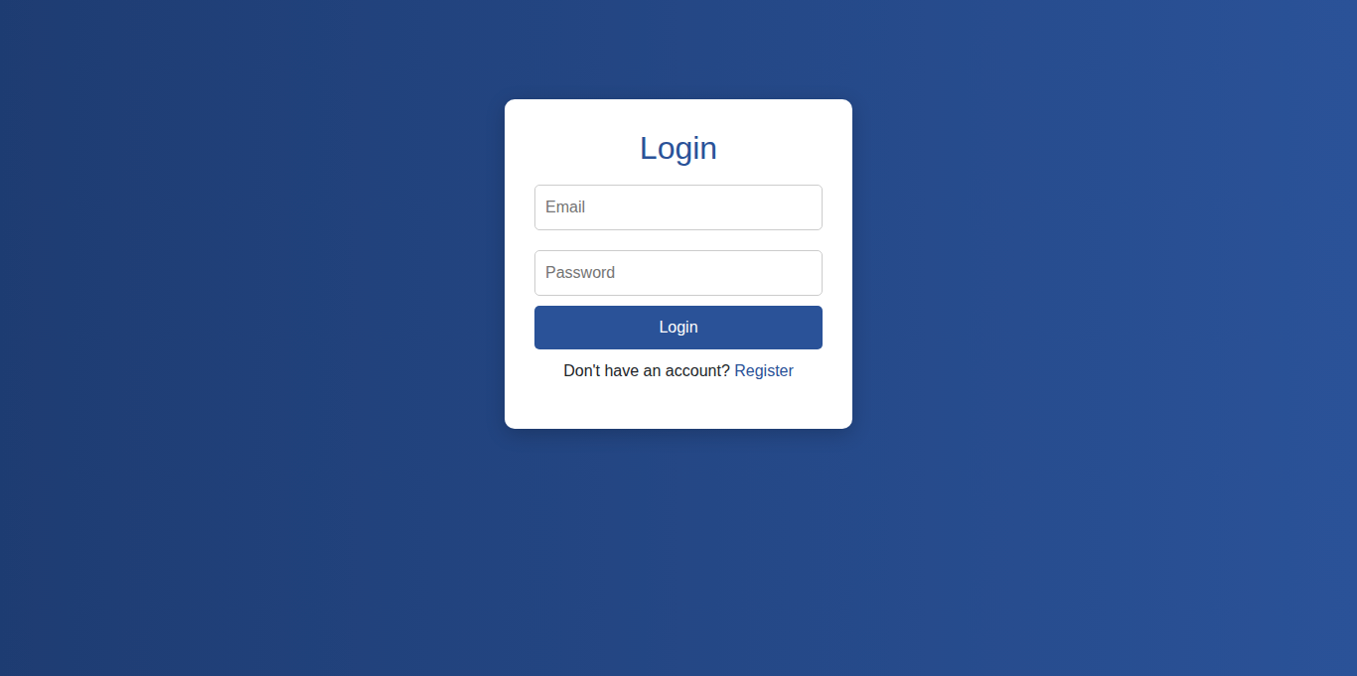
- Register Page
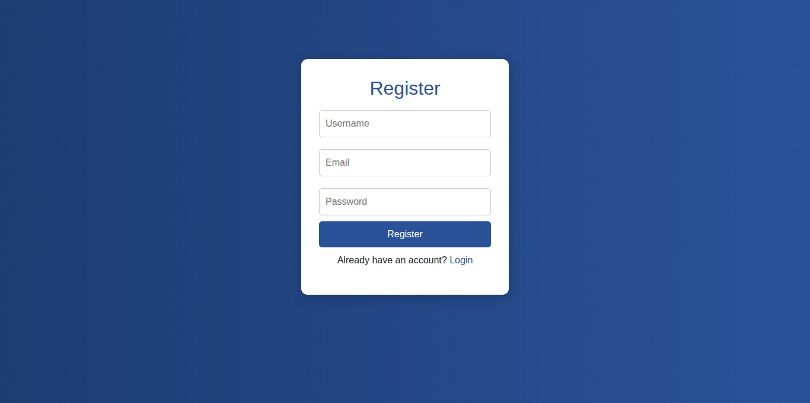

- Dashboard page
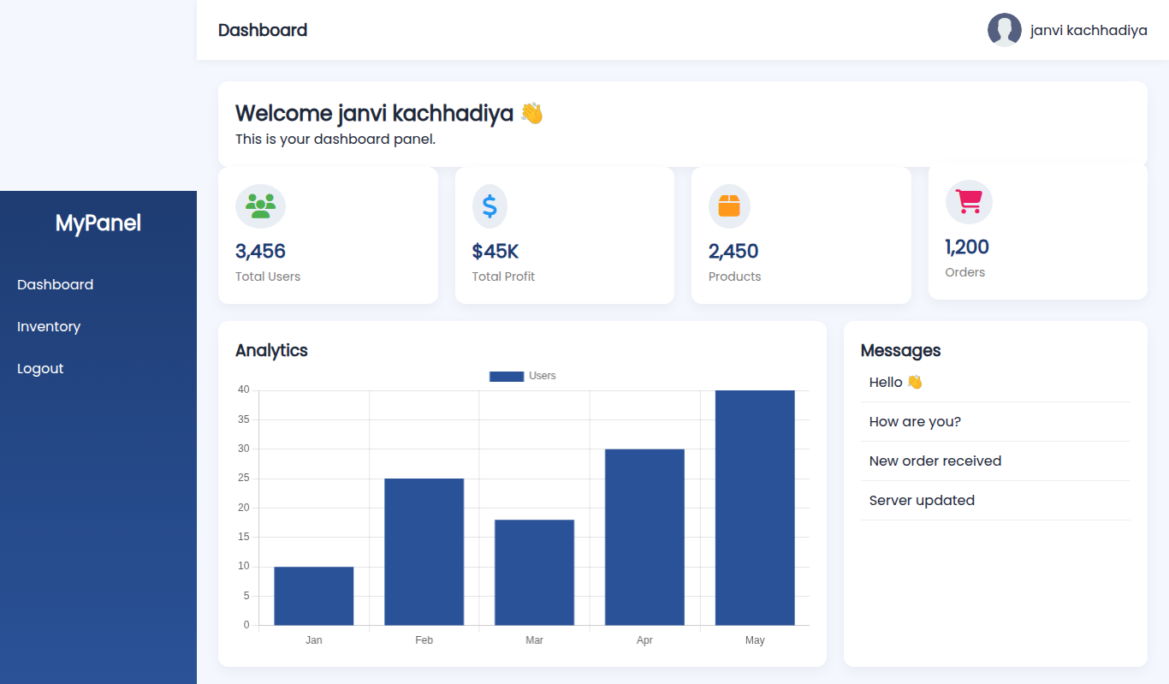
- All inventory page
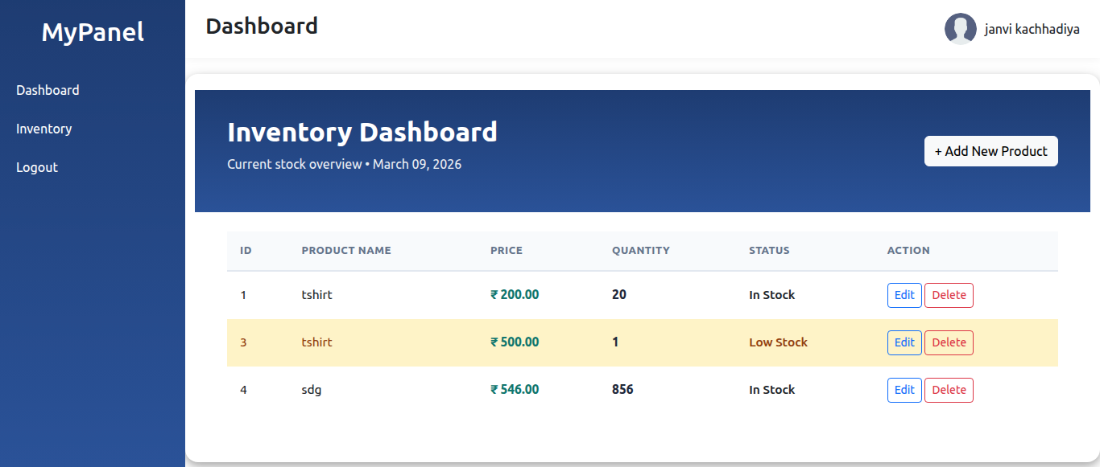

- Add product page
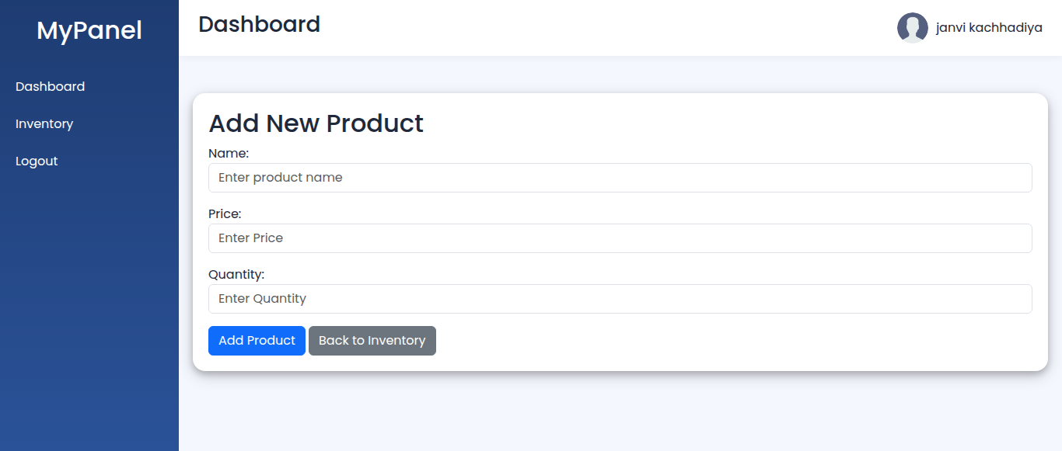
- Update product page
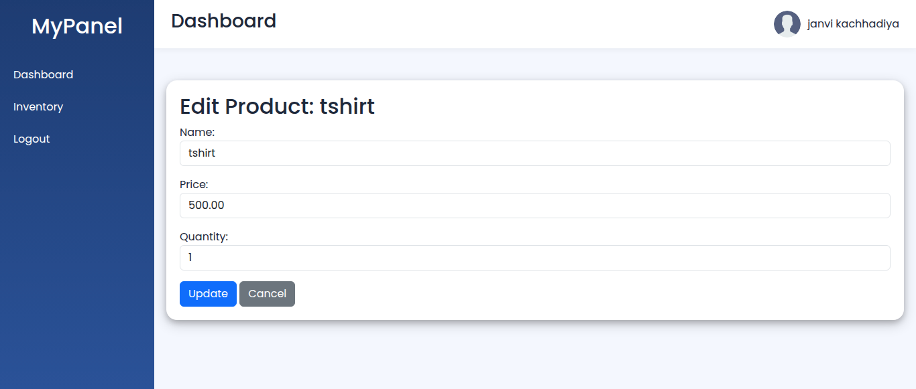

- Delete product page
